Few basic things about Java

1. What ever the name of the file there must be a class of same name
2. That class is always a public class
3. Inside this class there should be a main function, the function’s name has to be main by convention
4. The main function must be there, first it will look for the main function before running if there is no main function then the program will not run
5. main function is the entry point of the java program

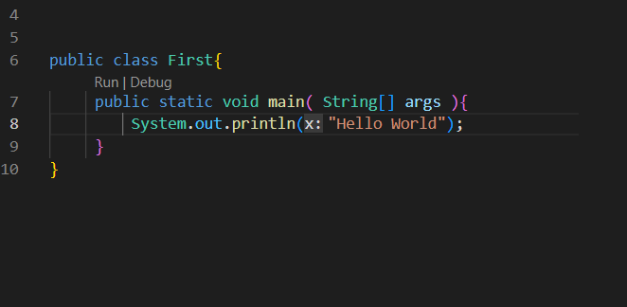

here the main function is the very first thing that will run, entry point of program. So it must run without creating object of the First class.

And we know static variables and functions are the ones that do not depend upon the objects

So we make the main function a static function which can run even without object creation of class

We have void because we are not returning anything by the main function

**Outputs in Java**



Here Among the facilities provided by the System class are standard input, standard output, and error output streams; access to externally defined properties and environment variables; a means of loading files and libraries; and a utility method for quickly copying a portion of an array

There's no such thing as a "static class" in Java. It's a class that has static fields/methods. System is not a "static class" (that only makes sense in a whole different context), but out is a static member of the System class, so you can use it on the class directly. You can't use System

So System is a class whose object we cannot create, but it provides various essential things

out is a variable / object of PrintStream class

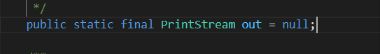



Also out is a static object so it do not need any object, it can directly run from the System class

Also println ( ) is a method inside the out object or PrintStream class

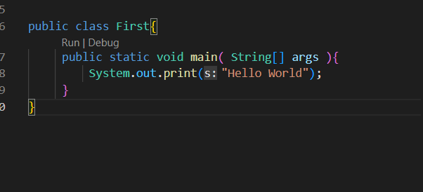

It is same but here we have print ( ) instead of println( ) where ln means new line

So we won’t have any new line after the output

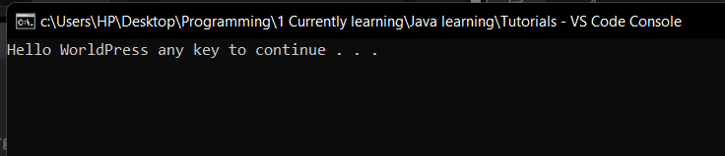

So this is basically how we output in the java

**Inputs in Java**

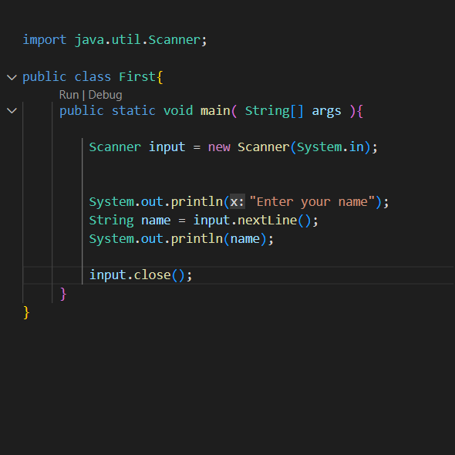

first we import the Scanner class

To use the Scanner class we than make the object of that class



here System.in refers to / points to the input stream, mainly keyboard

now with the help of input object ( Scanner object ) we can take input of various data types

And after the inputting is finished we must close the Scanner

**Primitive Data types in Java**

primitive data types are those data types which we can not further break in to other data types

for example

String name = “ Amrit poudel ”;

can we break string “Amrit poudel”

Yes, we can break it in to the individual characters, of char data type

So, string is not a primitive data type

**int, char, float( small decimal numbers ), double ( large decimal numbers ), long( large integer values ), bool**

these are the primitive data types

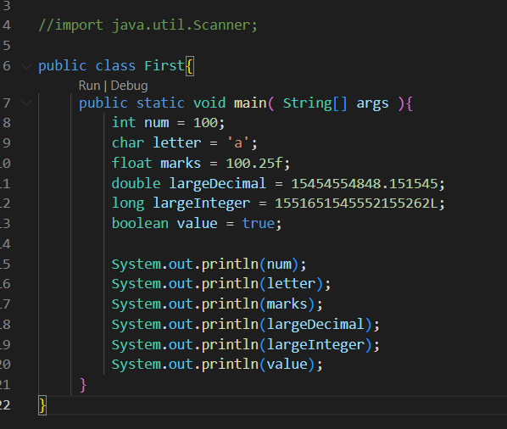

we use letter ‘ f ’ for floats and ‘ L ’ for large Integer

**Very handy and Important feature only available in Java**

In Java there are classes counterpart of all the primitive data types

like

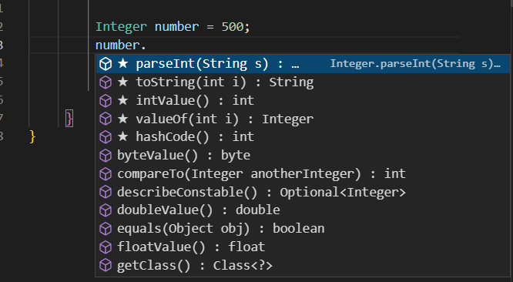

here number is an object of Integer class

Such classes are called wrapper classes

**Literals, Identifiers and Data Type**

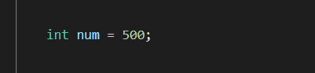

Here

int : data type

num : identifier

500 : literal, integer literal

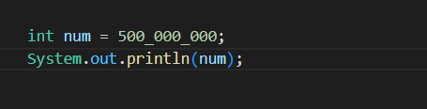

here _ is going to be ignored, and this actually means 500 millions